**e-Grips News 01.14.12** *Caption for Homepage News Section:* “The long awaited e-Grips update – It has been over a year we know… but we’ve been busy all the while!”

**News:** In the past year since we have updated, so much has happened it’s hard to sum it all up. e-Grips were all over comp walls in 2011 from ABS Nationals in Boulder to the Nor’easter in Burlington, Vermont and in Central Park for the EMS Pro in between. The most recent event we sponsored was the first Lead World Cup in over 20 years, which our e-Grips Sales Captain Chris Danielson was the Chief US Routesetter for. Check out the video! *(Please embed the following link)* http://jonglassberg.lt11.com/2011/10/13/2011-ifsc-lead-world-cup-boulder-colorado/

We apologize for not updating all of the new sets, but, for those that have been part of the family, getting new shapes each month, e-Grips First Dibs program has been as popular as ever. For those of you interested in First Dibs, you can always contact Chris Danielson at [cdanielson@gthi.com](mailto:cdanielson@gthi.com) for any info about the most recent sets or any e-Grips questions in general. We will be updating the individual website pages over the coming weeks with all of the new sets shown below. Here are pictures of all of the First Dibs from 2011 and the last months of 2010, all now available as a part of the complete e-Grips line:

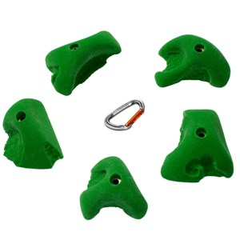 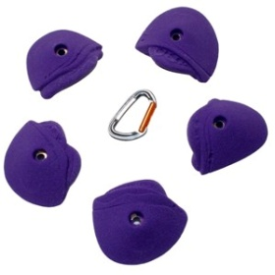 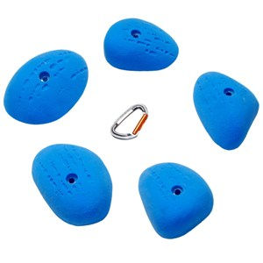 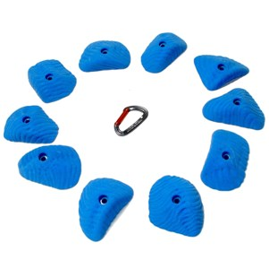

**REMARKABLE ROCKS PINCHES CATERPILLAR FINGER BUCKETS MO JOE’S SLOPERS MYORCAN SLOPER EDGES**

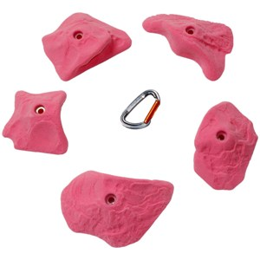 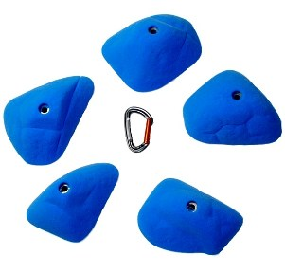 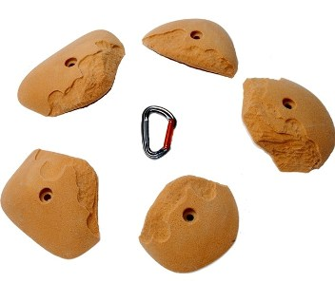 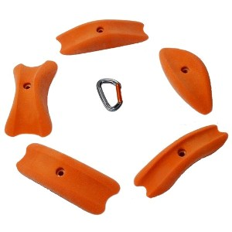

**REAL HUECO DIRECTIONALS HORSE PENS MODERATES PEABODY FLAKE JUGS MEDIAN LOAVES**

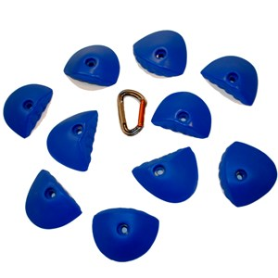 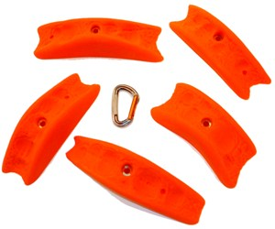 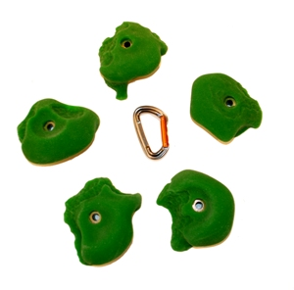 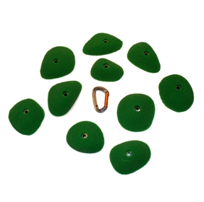

**2TEX BUBBLE WRAP CRIMPS QUARRY PINCHES REMARKABLE ROCKS MINI-JUGS ZEN SP SLOPERS**

We have had a bunch of other new sets too of course! The Bubble Wrap Beehive and Jibber Jabber Super Jugs were released just in advance of ABS Nationals last season. The Beehive speaks for itself and has already been featured in dozens of competitions. The Jibber Jabber Super Jugs is a set of 5 deeply incut single-hand jugs, perfect for easy climbing on steep walls. All the shapes in this set were modeled after the near-perfect single shape from the original Jibber Jabbers – those of you that have the set know which one we’re talking about!

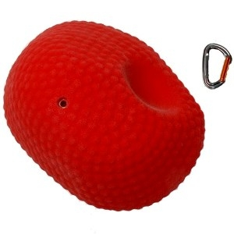 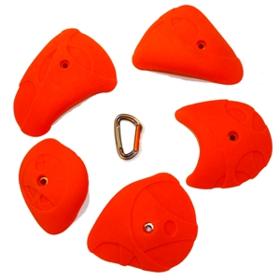

**BUBBLE WRAP BEEHIVE JIBBER JABBER SUPER JUGS**

A new theme we also added last year, is a Training style of shapes – purely symmetrical shapes for left or right hands - function oriented – great for the System Board or home training wall, but also great to force movements, as was shown in the Lead World Cup in Boulder, where the Men’s Final had the top climbers in the world spinning around on bright orange Pure Power Pockets II. We may expand on this line in the future, but for now we have four sets – Pure Power Edges I and II, and Pure Power Pockets I and II. Enjoy!

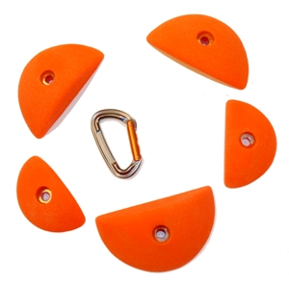 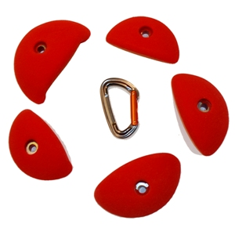 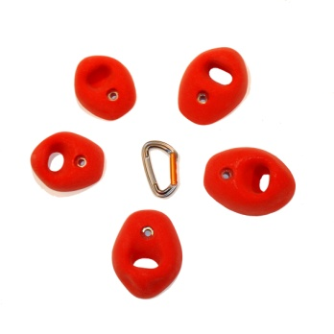 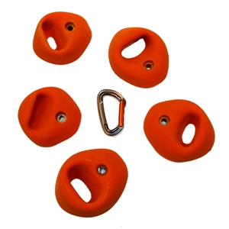

**PURE POWER EDGES I PURE POWER EDGES II PURE POWER POCKETS I PURE POWER POCKETS II**